**Assignment -3** IBM CLOUD

**Question-1:**

Create a Bucket in IBM object storage.

**Solution:**

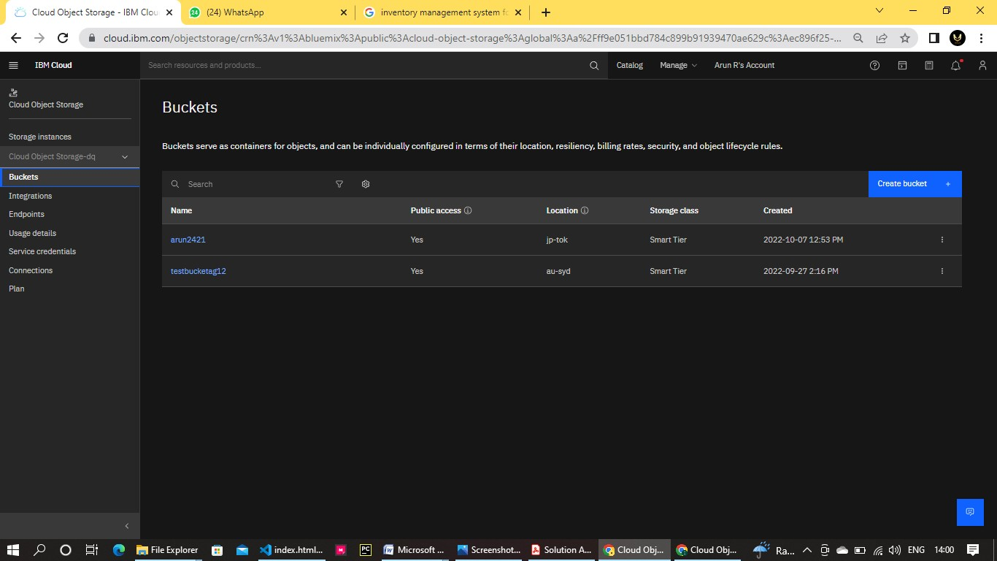

**Question-2 & 3:**

Upload an 5 images to ibm object storage and make it public .write html code to displaying all the 5 images. Upload a css page to the object storage and use the same page in your HTML code.

**Solution:**

**Index.html**

<!DOCTYPE html>

<html>

<head>

<link rel="stylesheet" href="stylesheet.css">

</head>

<body>

<center>

<h2> INVENTORY MANAGEMENT</h2>

</center>

<div class="row">

<div class="column">

<img src="img4.jpg" alt="Snow" style="width: 100%;">

</div>

<div class="column">

<img src="invt.jpg" alt="Forest" style="width: 100%;">

|  |
| --- |
| </div>  <div class="column">  <img src="img2.jpg" alt="Mountain" style="width: 100%;">  </div>  <div class="column">  <img src="img3.jpg" alt="Mountain" style="width: 100%;">  </div>    <div class="column">  <img src="img.jpg" alt="Mountain" style="width: 100%;">  </div>  </div>  </body>  </html> |
|  |

**Style.css**

|  |
| --- |
| *{ box-sizing: border-box;  }  .column { float: left; width: 33.33%; padding: 5px;  }  .row::after { content: ""; clear: both; display: table;  } |

**IBM OBJECT STORAGE :**

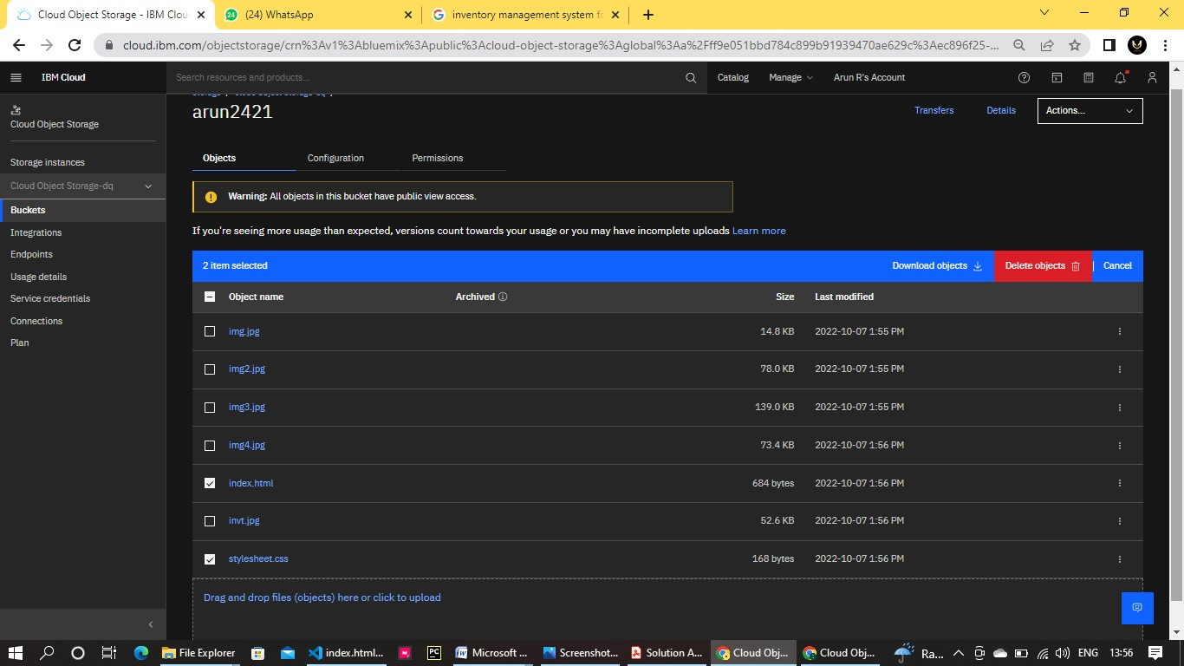

**Output :**

<https://arun2421.s3.jp-tok.cloud-object-storage.appdomain.cloud/index.html>